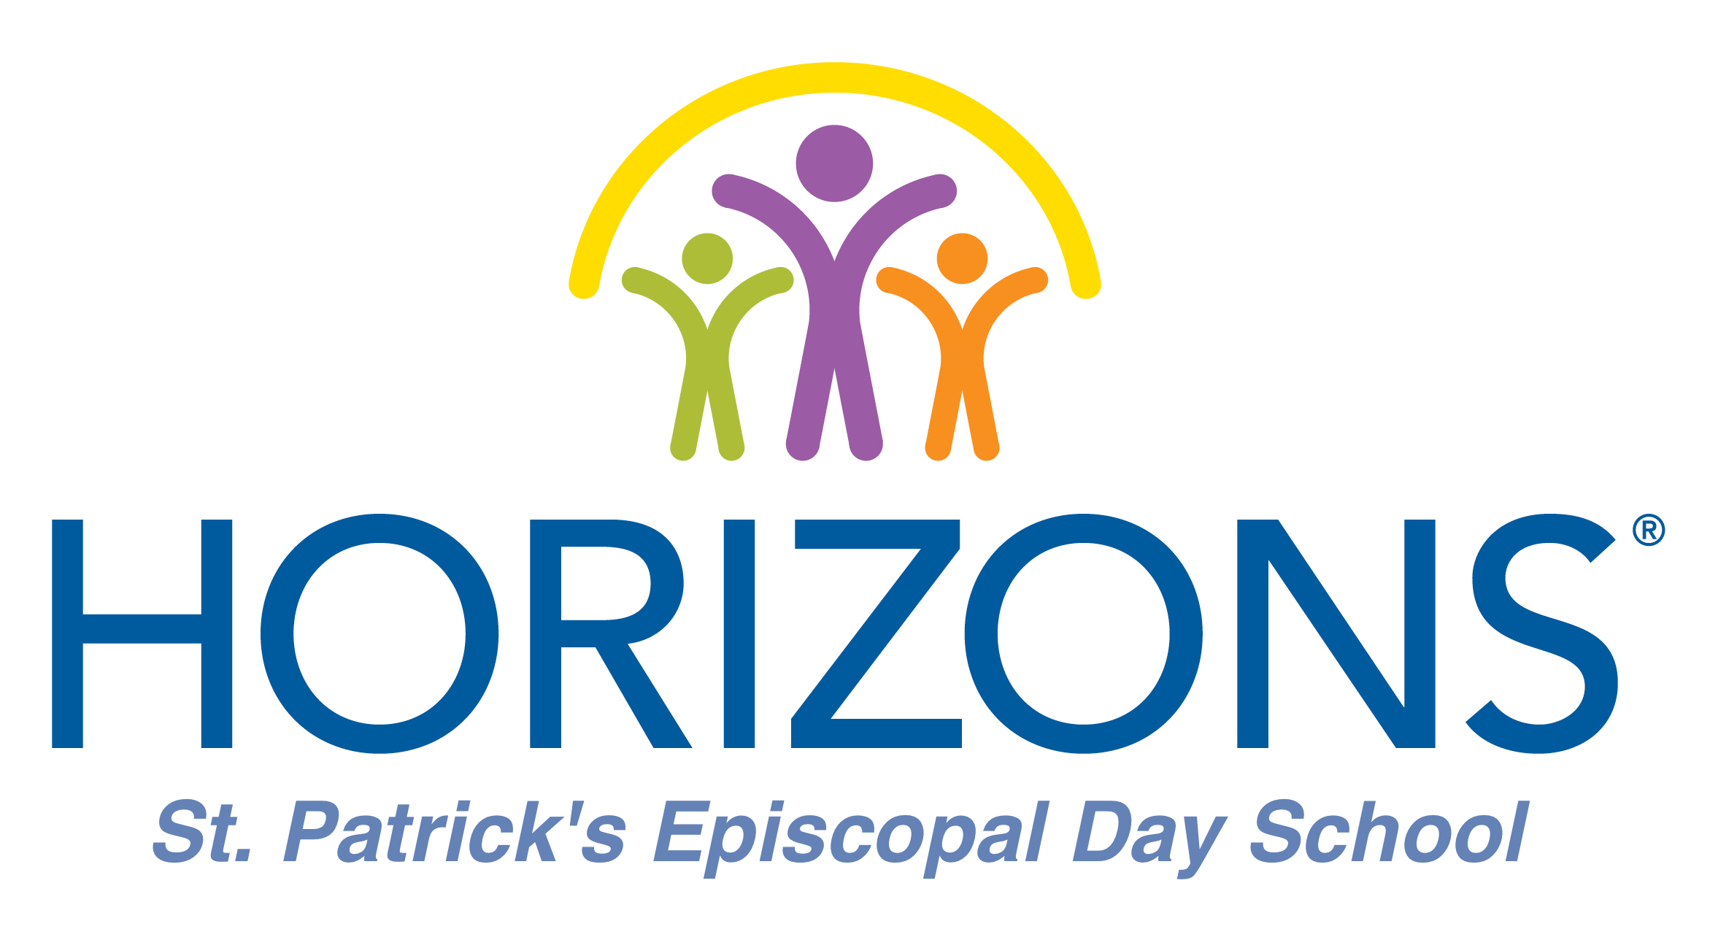
Position: Science Teacher, Grades 1-5
Horizons Greater Washington develops public private partnerships between independent and public school communities to provide academic, cultural, and recreational programs designed to empower economically disadvantaged students to realize their full potential. We are currently located at three sites: Maret School, Norwood School, and St Patrick’s School.

Horizons Greater Washington employs dedicated and enthusiastic educators with a dynamic talent of creating and nurturing a lifelong love of learning in children. A core component of our program is providing engaging and hands-on lessons for our students. We look for experienced, professional individuals with the ability to implement strategies to engage students in active learning through non-traditional methods in our six-week summer enrichment program. Candidate must work as a team player to help fulfill the Horizons mission.

For more information about Horizons, please visit www.horizonsgreaterwashington.org.

General Description:
The Lead Teacher’s areas of direct responsibilities include but are not limited to:
- Perform classroom duties of teaching 45-minute science/technology/engineering/math (STEM) lessons for classes of 15 students, grades 1-5. Each grade will meet twice a week.
- Work in partnership with classroom teachers to design lessons that complement homeroom lessons.
- Collaborate with and mentor teaching assistants from each class that accompany the students to STEM class.
- Maintain attendance records, write lesson plans, teach lessons, and provide evaluative feedback.
- Set up and maintain a classroom that creates a space for positive learning.
- Provide a brief evaluative comment on each student at the end of the summer.
- Attend events outside the school day including Family Night and Faculty Meetings as well as all other duties that may be required.
- Attend a one-week orientation session prior to the start of the program. Timing will depend on scheduled workshops as well as individual classroom prep.
- Ride the bus for pick-up and drop-off and provide supervision for the students.

Summer 2017 Dates:
Monday, June 19 - Friday, June 23: Teacher orientation week and classroom set-up
Monday, June 26 - Friday, August 4: Six-week program

Please send a cover letter and resume to:
Rachel Levin
Horizons Site Director
St. Patrick’s Episcopal Day School
levinr@stpatsdc.org

