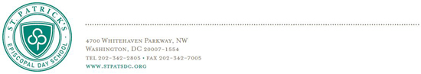
June 9, 2017
Dear Parents of Rising Grades 1, 2, and 3 Students,
As we move into the summer months, we want to provide you with the link for the Summer Reading List for the grade your child is entering here. This link is also available on the St. Patrick’s website, under Quicklinks. Our expectation is that all Lower School students will read daily (or be read to, read aloud, or some combination of the three) during the summer months for at least twenty to thirty minutes.
Students entering Grades 1 and 2 should also complete the appropriate summer reading log, attached here and also available at the link above, on which they can write the names of several books read over the summer. This sheet will be collected in September to share with classmates and teachers. Rising Grade 3 students have one required book to read this summer—Jake Drake Bully Buster by Andrew Clements.
Please also note that many of these titles are available for purchase through the St. Patrick’s Amazon store. Purchasing through this link will direct a portion of the proceeds to the St. Patrick’s Parents Association.
Spending time each day reading aloud to you, reading independently, and listening to good books helps maintain, solidify, and increase reading skills over the summer. We hope you and your children find this list of suggested titles a helpful resource in selecting books to enjoy over the summer. As a reminder, when children are choosing books to read independently, it is important that they choose books that are “just right” for them. Reading books on a comfortable level strengthens decoding skills, improves overall fluency, and increases comprehension.
I wish you all a wonderful summer and hope that you all find the time to enjoy some summer reading!
Best,

Jenifer Congdon
Head of Lower School

